**1.1.4**

<html>

<body>  
<p>This is my first paragraph</p>  
</body>

</html>

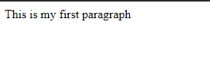

1.2.1

<html>

<body>  
<h1>This is a heading</h1>  
<h2>This is a heading</h2>  
<h3>This is a heading</h3>  
</body>

</html>

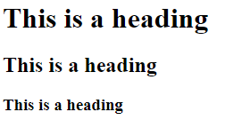

1.2.2

<html>

<body>  
<p>This is a paragraph</p>  
<p>This is another paragraph</p>  
</body>

</html>



<html>

<body>

<p>This is<br />a para<br />graph with line breaks</p>

</body>

</html>

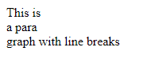

1.2.3

<html>

<body>

<a href="http://www.w3schools.com">This is a link</a>

</body>

</html>



1.2.4

<html>

<body>

<img src="w3schools.jpg" width="104" height="142" />

</body>

</html>

1.3.1

<html>

<body>

<a href="http://www.w3schools.com">This is a link</a>

</body>

</html>



1.4.2

<html>

<body>

<a href="url">Link text</a>

</body>

</html>



1.4.3

<html>

<body>

<a href<a href="http://www.w3schools.com/">Visit W3Schools!</a>

</body>

</html>



1.4.4

<html>

<body>

<a href="http://www.w3schools.com/"  
target="_blank">Visit W3Schools!</a>

</body>

</html>



1.4.5

<html>

<body>

<a name="label">Any content</a>

</body>

</html>

